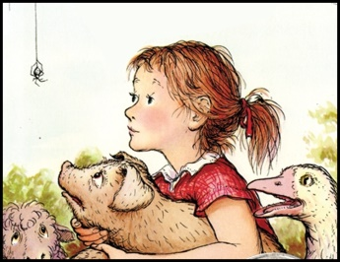
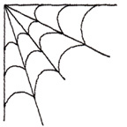
Name:_______________________________Date: 4/23/18-4/27/18
Vocabulary:
Runt: An unusually small animal.
Injustice: Not fair.
Specimen: A part that shows what the whole thing or group is like.
Enchanted: Delighted; Captivated.
Sheepfold: A pen or shelter for sheep.
Commotion: Confusion; Noise.
Reconsider: To consider again; Thinking about again.
Appetizing: Something tempting; Appealing
Captivity: The state of being held against your will or in confinement.
Scythe: A tool for cutting grain, having a long curved blade on handle.
TEST: 4/27/18

Spelling: |  | Charlotte |  | Web | Reconsider | Spider | Runt | Escape | Springtime | Feelings
Farm | Breakfast |  | Animals | Barn | Pigpen | Wilbur | Injustice |  | TEST: 4/27/18
Directions: Pick an activity from the list below every night. ONE for vocabulary and ONE for Spelling. Activities will be checked on a DAILY basis. Work must be labeled (vocabulary/spelling and the date) I will not accept late work!
 | Monday: | Tuesday | Wednesday | Thursday
Vocabulary: | Write sentences with vocabulary words. | Find your word in the book. Then in your own words tell me what the word means and the page # where you found the word. | Create an illustration for each vocabulary word. | Write a synonym and antonym for each vocabulary word.
Spelling: | Write spelling words 3 times each | Write spelling words in silly writing. | Create a ladder with your spelling words. | Put spelling words in alphabetical order.
Activities:

