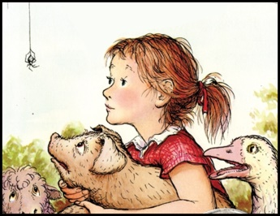
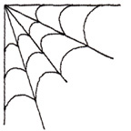
Name:_______________________________Date: 4/30/18-5/04/18
Vocabulary:
Provender: A dry food for animals
Morsel: A small piece of food.
Glutton: A person or animal that overeats.
Inheritance: Something you get from a person at his death.
Morals: Lessons to be learned from a story or experience.
Decency: Modest or proper behavior.
Frolic: To have fun by running, skipping, or hopping.
Consideration: Thoughtfulness for other people.
Hysterics: To cry loudly in reaction to bad news
Meekly: In a gentle, cooperative manner.
TEST: 5/04/18

Spelling: |  | Morals |  | Conscience | Trough | Morsal | Sheep | Gosling | Spin | Slops
Salutations | Gander |  | Goose | Detested | Glutton | Summer | News |  | TEST: 5/04/18
Directions: Pick an activity from the list below every night. ONE for vocabulary and ONE for Spelling. Activities will be checked on a DAILY basis. Work must be labeled (vocabulary/spelling and the date) I will not accept late work!
 | Monday: | Tuesday | Wednesday | Thursday
Vocabulary: | Write sentences with vocabulary words. | Find your word in the book. Then in your own words tell me what the word means and the page # where you found the word. | Create an illustration for each vocabulary word. | Write a synonym and antonym for each vocabulary word.
Spelling: | Write spelling words 3 times each | Write spelling words in silly writing. | Create a ladder with your spelling words. | Put spelling words in alphabetical order.
Activities:

